Chapter 6, Problem 63.

In the circuit in Fig. 6.85, sketch v_{o}.

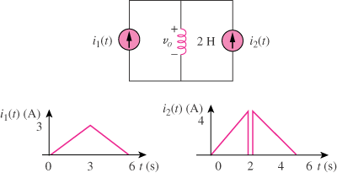

Figure 6.85
For Prob. 6.63.

